1. Printing Patterns

Problem: Write a Java program to print patterns such as a right triangle of stars.

Test Cases:

Input: n = 3

Output:

\*

\*\*

\*\*\*

Input: n = 5

Output:

\*

\*\*

\*\*\*

\*\*\*\*

\*\*\*\*\*

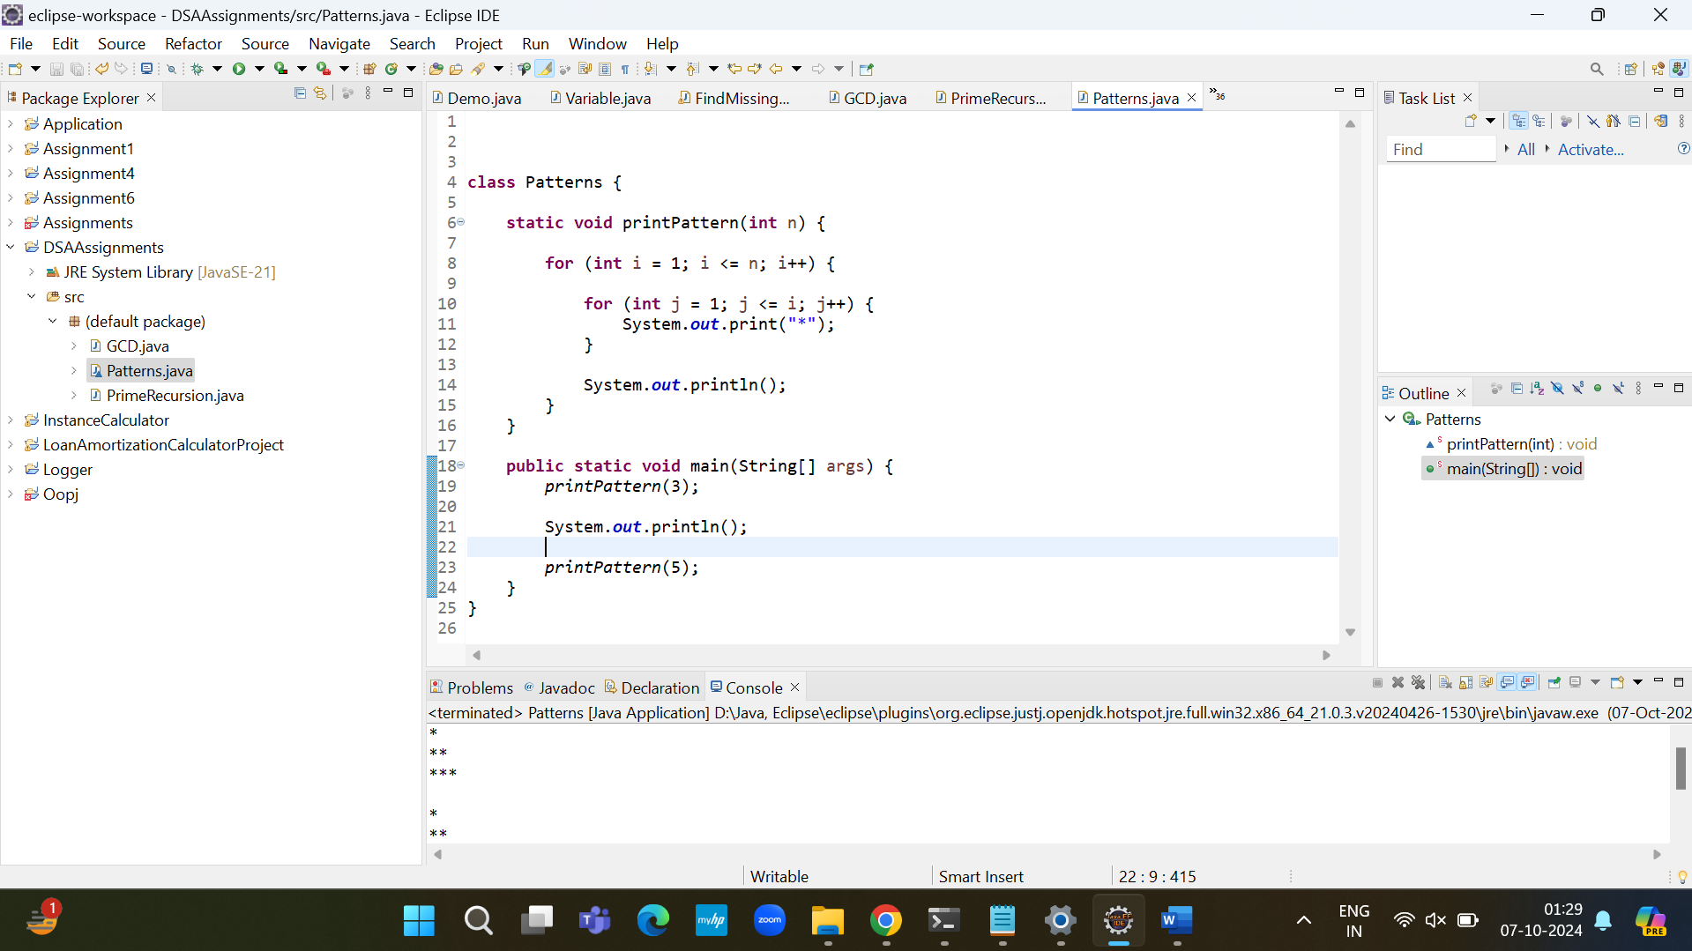

Time Complexity: O(n^2) , as there are nested loops.

2. Remove Array Duplicates

Problem: Write a Java program to remove duplicates from a sorted array and return the new length of the

array.

Test Cases:

Input: arr = [1, 1, 2]

Output: 2

Input: arr = [0, 0, 1, 1, 2, 2, 3, 3]

Output: 4

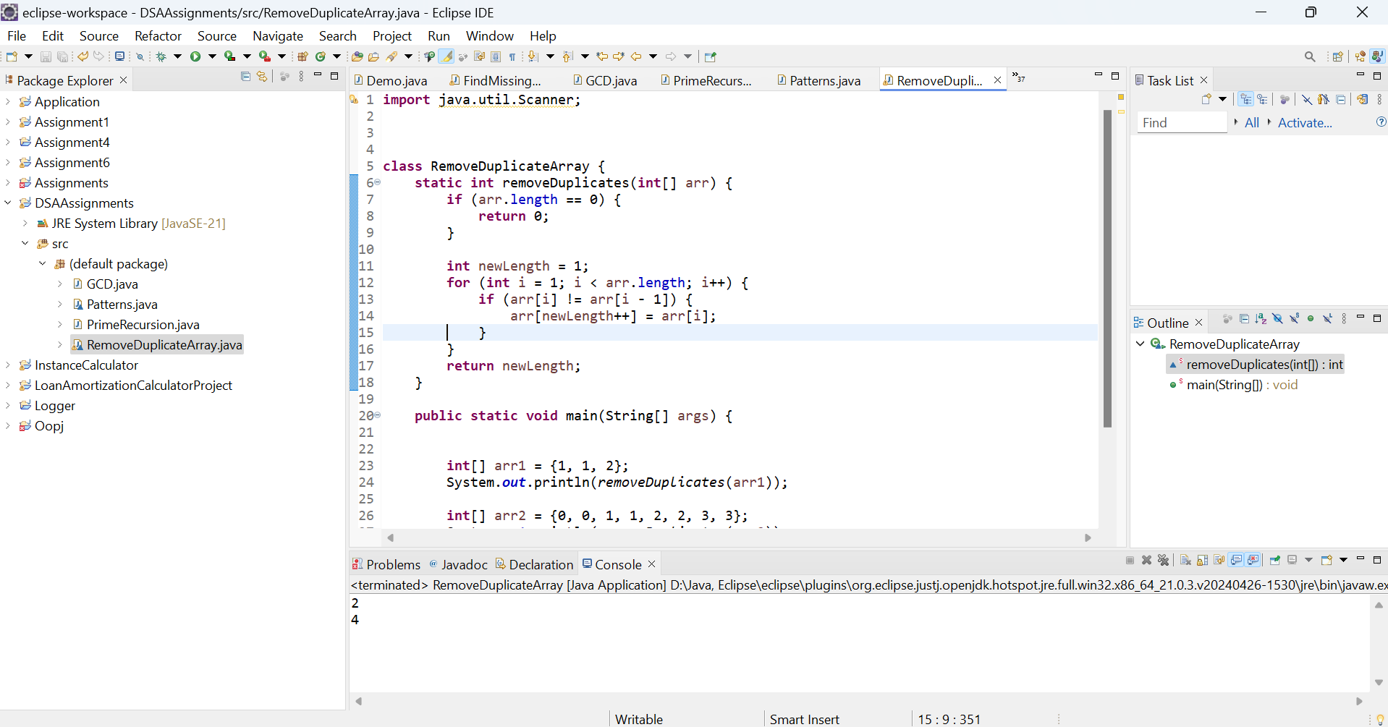

T.C – O(n), as we go through array full length.

3. Remove White Spaces from String

Problem: Write a Java program to remove all white spaces from a given string.

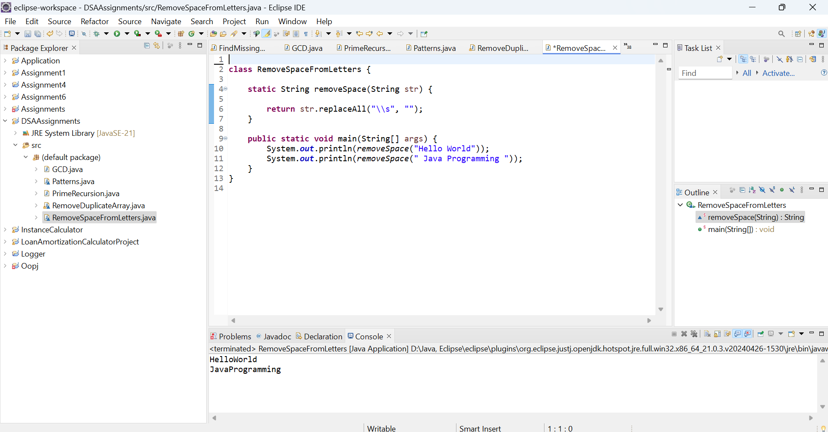

Reverse a String

Problem: Write a Java program to reverse a given string.

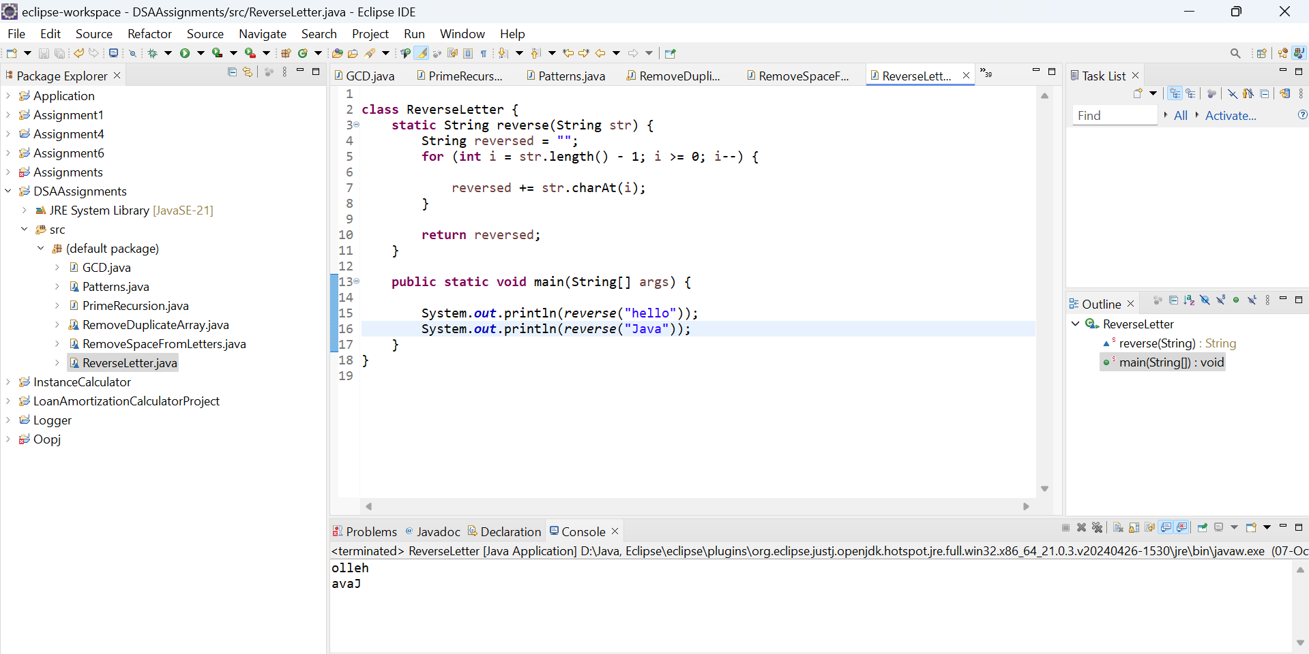

Reverse Words in a String

Problem: Write a Java program to reverse the words in a given sentence.

